Plano ISD Secondary English Language Arts and Reading (ELAR) Adopted Curriculum Resources
Courses | Adopted Resource & Publisher | Format | Student  Webdesk App | Textbook Image
Middle School  English Language  Arts | Savvas Learning MyPerspectives | Students are provided access to a hardbound textbook for checkout and online access to their digital book through PISD Webdesk. | 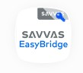 | 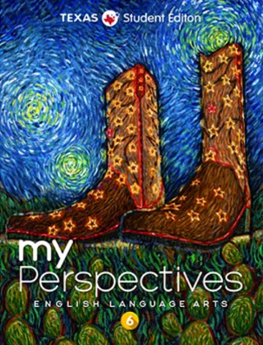
Middle School Reading 7 & 8 | Savvas Learning MyPerspectives | Students are provided access to a hardbound textbook for checkout and online access to their digital book through PISD Webdesk. |  | 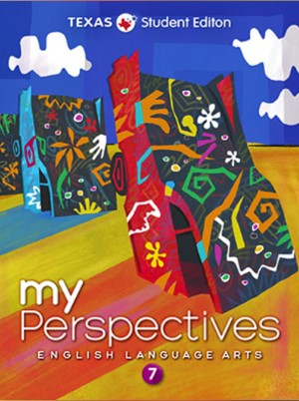
Middle School Reading 7 & 8 | Savvas Learning QReads | Students are provided differentiated ancillary materials based on their identified instructional reading level. | N/A | 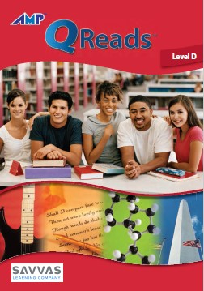
Middle School Reading 7 & 8 | MindPlay | Students are provided access to the online MindPlay program through PISD Webdesk | 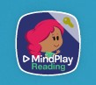 | N/A
High School  English I-IV  (all levels) | McGraw Hill StudySync | Students are provided access to a hardbound textbook for checkout and online access to their digital book through PISD Webdesk. | 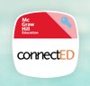 | 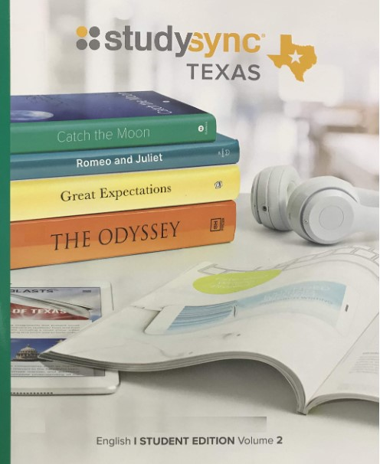
AP English  Language (AP  English III) | The Language of  Composition: Reading,  Writing, Rhetoric. Third  Edition (Bedford, Freeman  & Worth) | Students are provided a hardbound textbook for checkout and online access to their digital e-book. |  | 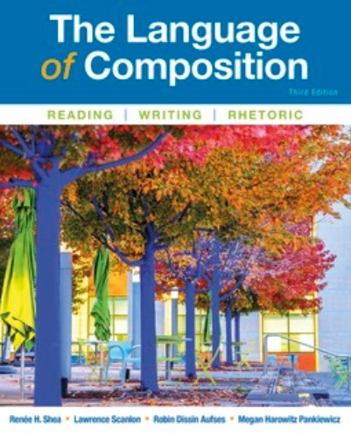
AP English  Literature (AP  English IV) | Literature & Composition:  Reading, Writing, Thinking.  Second Edition (Bedford,  Freeman & Worth) | Students are provided a consumable textbook and online access to their digital book through PISD Webdesk. |  | 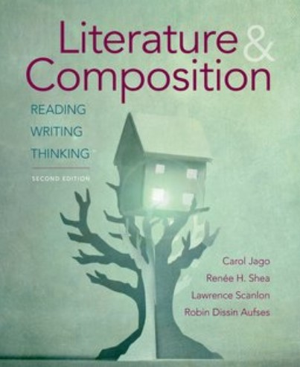
*Resources for AP, IB, and Dual Credit courses may vary by instructor and by year, to align with governing organizations.

